Report Lab03
Name: Ngô Văn Đông
Student ID: 20235486

Use case Diagram and Class Diagram
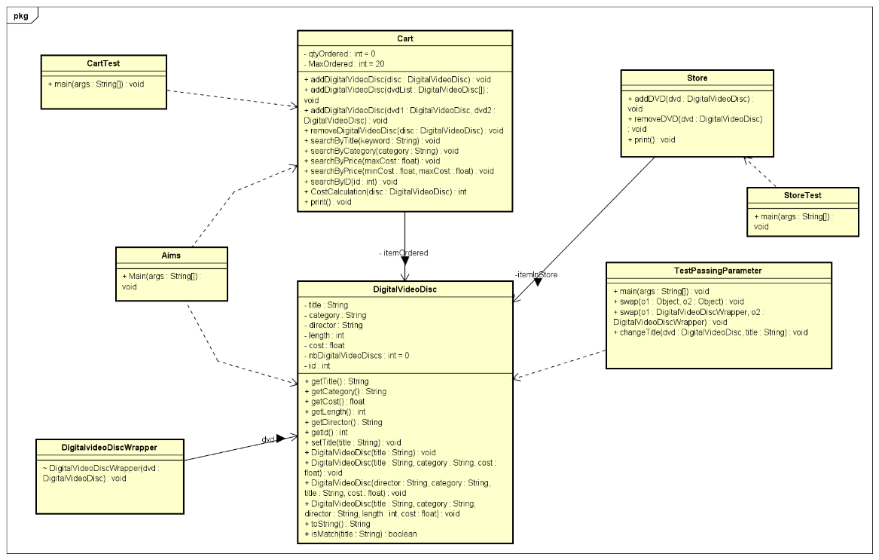
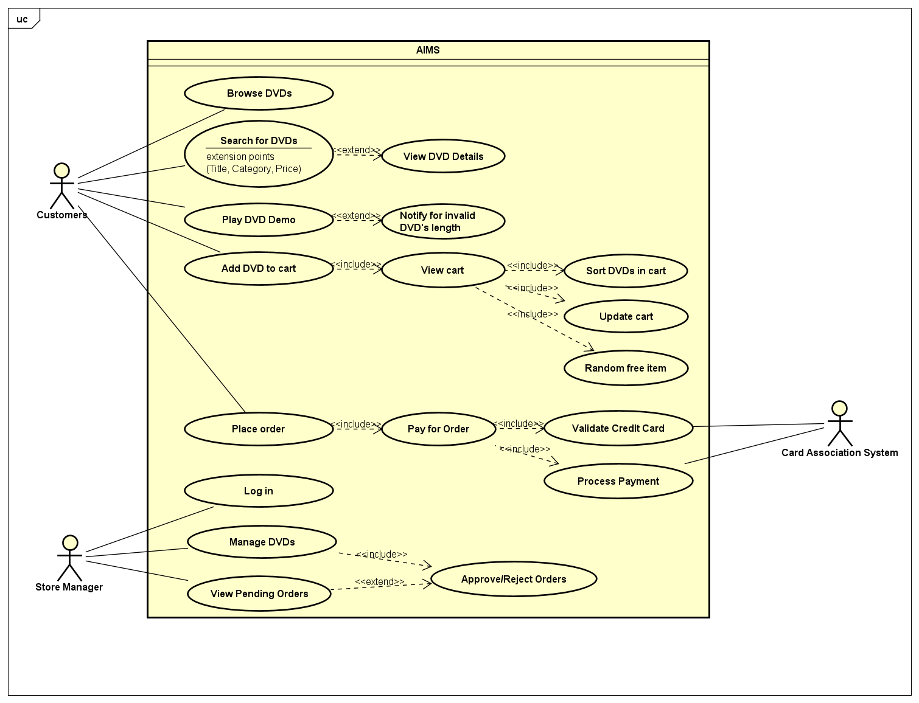

Working with method overloading
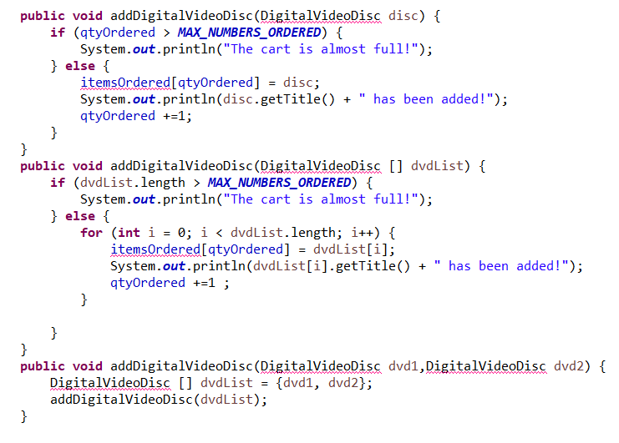
Passing parameter
True swap method:
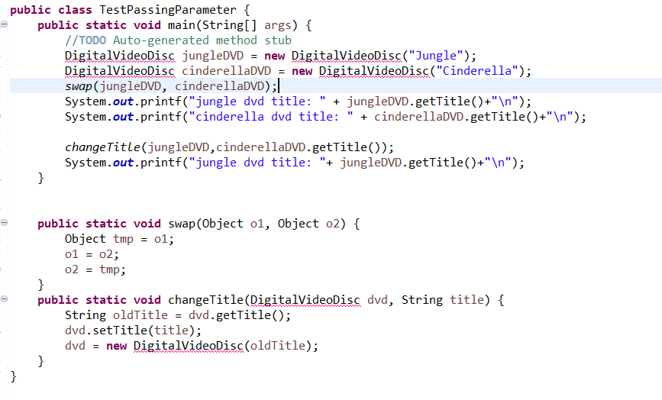
1. Is JAVA a Pass by Value or a Pass by Reference programming language?
Answer: In Java, variables of primitive types (such as int, float, boolean) are passed by value, while variables of reference types (such as objects) are passed by value as well, but the value being passed is a reference to the object. This is often a source of confusion when discussing whether Java is pass by value or pass by reference. When a method is called in Java and arguments are passed to it, the values of the variables are copied and passed to the method.
For primitive types, the method receives a copy of the value, and any changes made to the copy within the method do not affect the original value outside the method.
For reference types, the value being passed is a reference to an object in memory. The method receives a copy of this reference, so changes made to the reference itself within the method (e.g., assigning a new object to the reference) do not affect the original reference outside the method.
However, the method can still modify the state of the object itself (e.g., modifying its properties or invoking its methods), and these changes will be visible outside the method because both the original reference and the method's copy refer to the same object in memory.
To summarize, Java is strictly pass by value, but for reference types, the value being passed is a copy of the reference, not the object itself.

2. After the call of swap(jungleDVD, cinderellaDVD) why does the title of these two objects still remain?
Answer: Because the swap() method is exchanging the values of the title fields between the two objects, but it's not changing the object references themselves. So the jungleDVD and cinderellaDVD object references still point to the same objects in memory as before the swap() method call.

3. After the call of changeTitle(jungleDVD, cinderellaDVD.getTitle()) why is the title of the JungleDVD changed?
Answer: Because the changeTitle() method is modifying the title field of the jungleDVD object directly using the setter method.

Debug
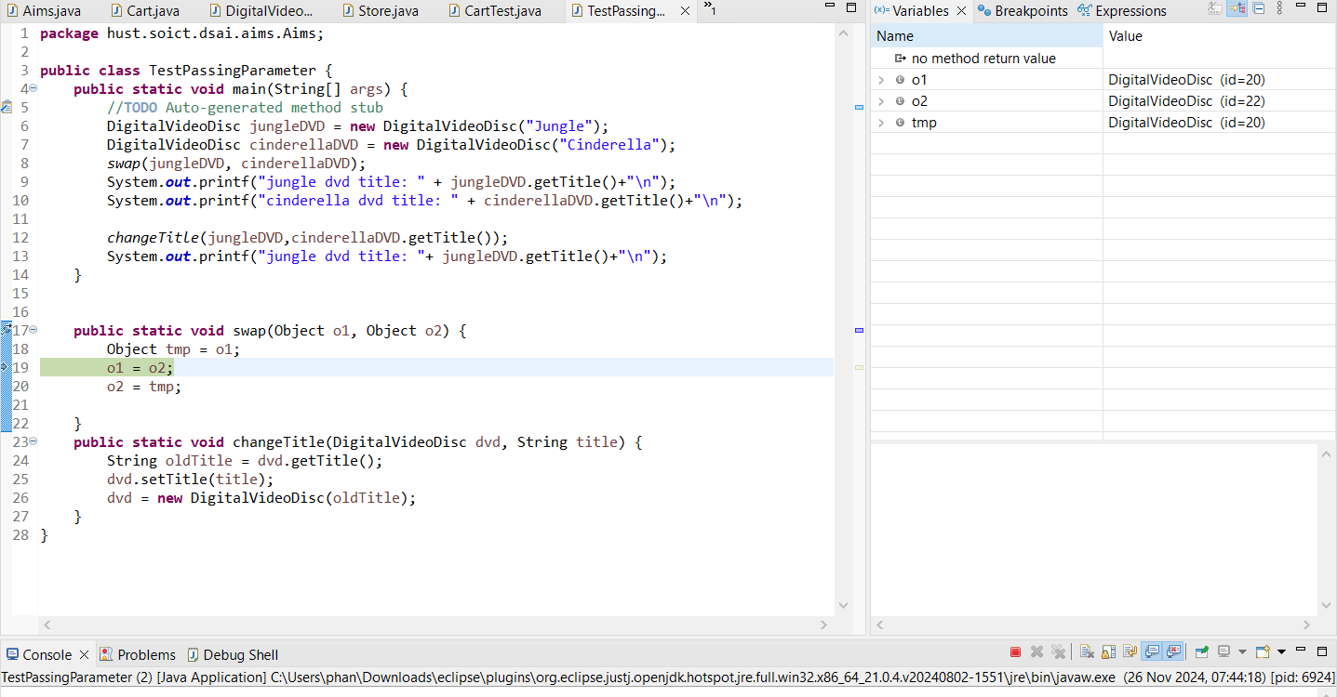
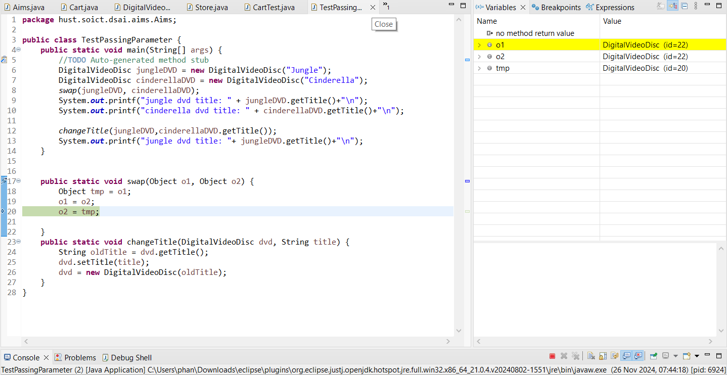
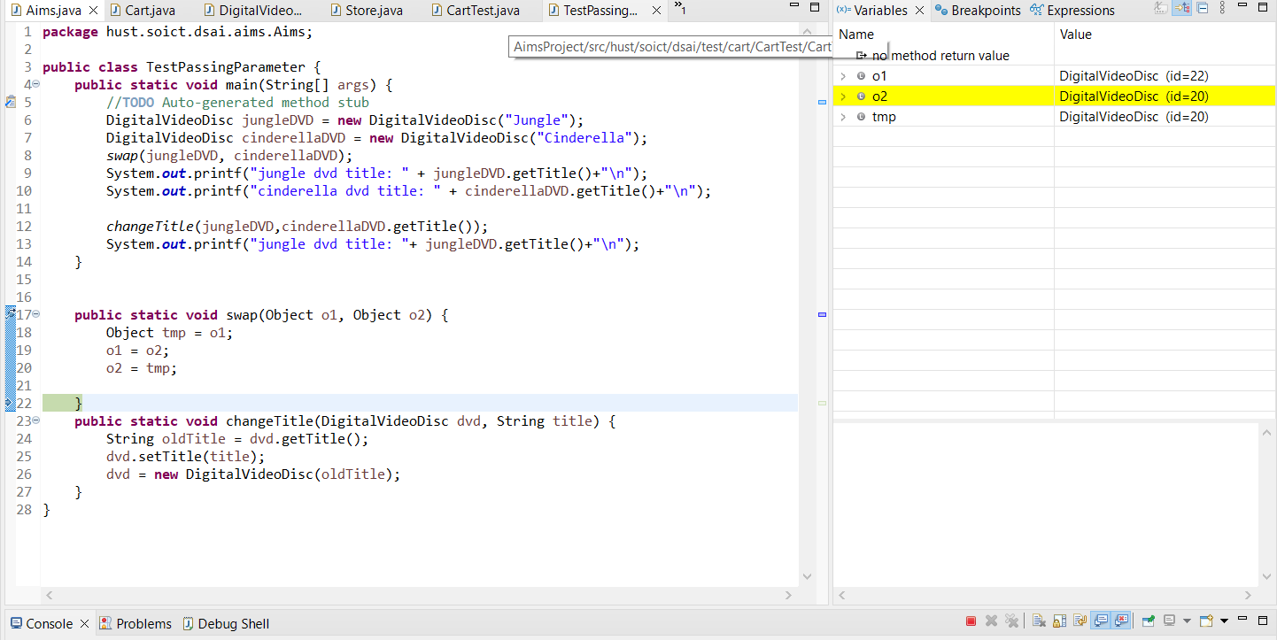
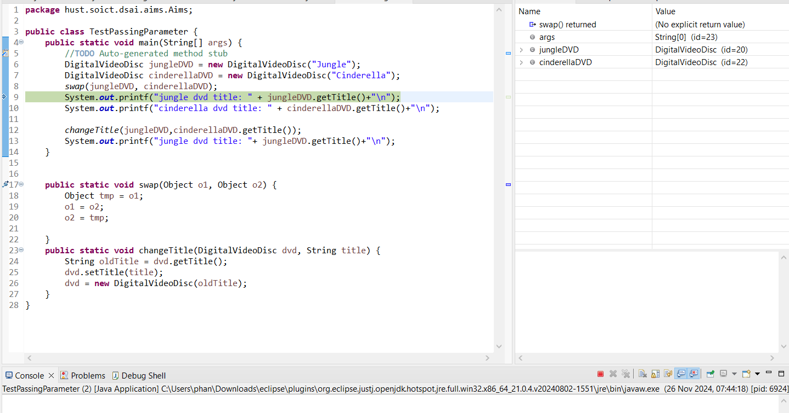
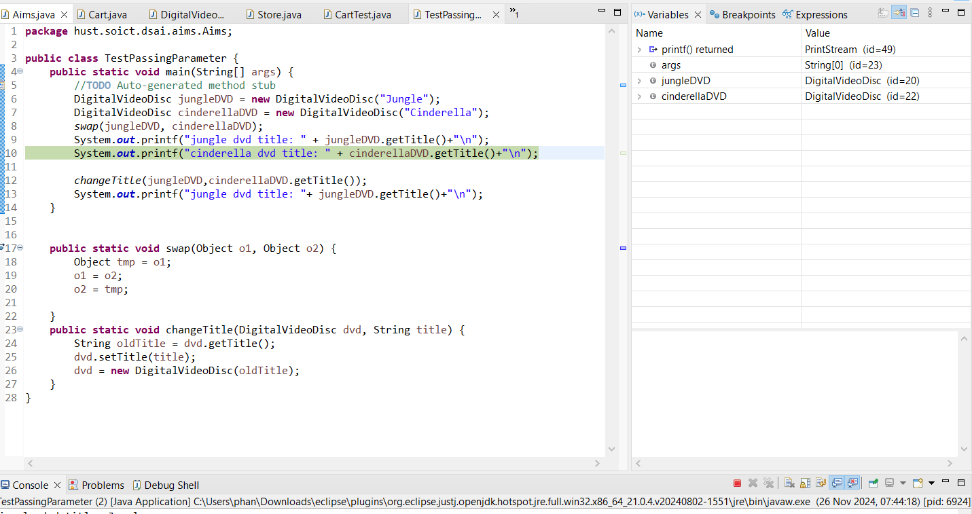
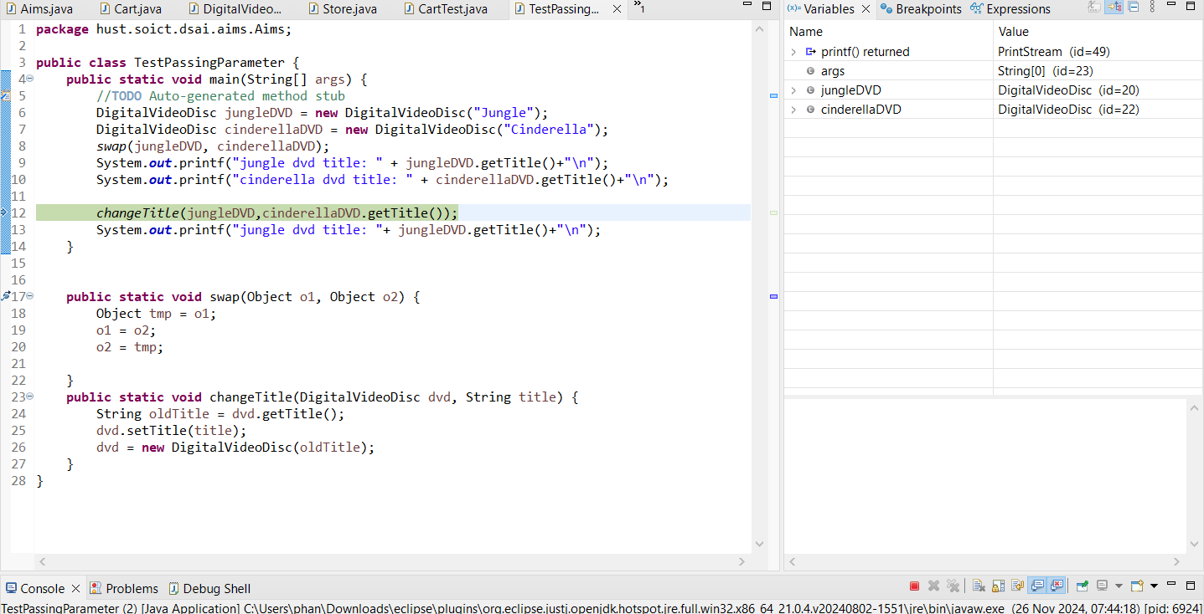
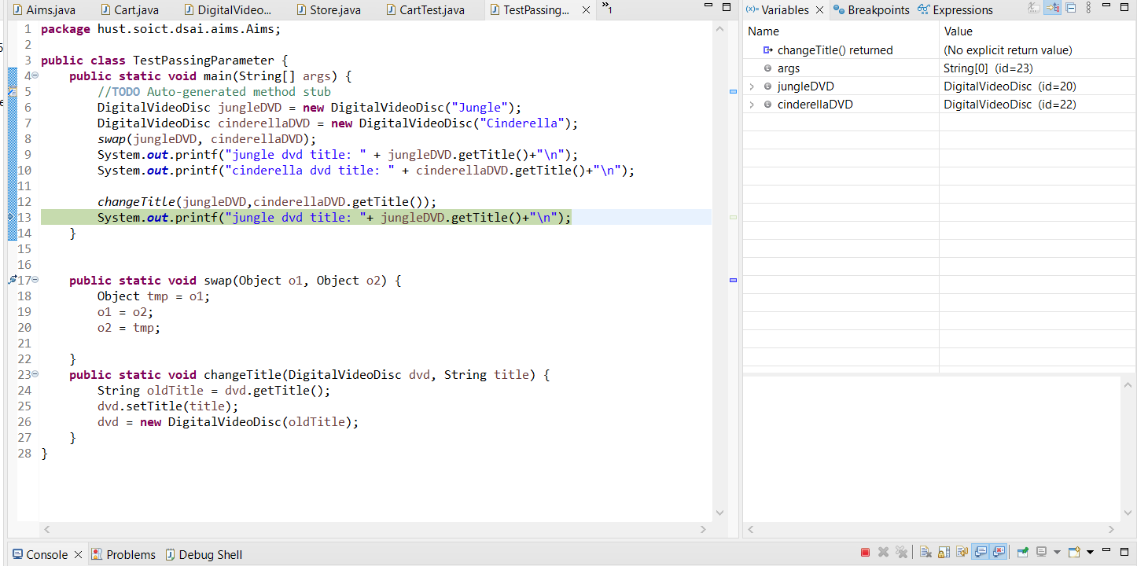
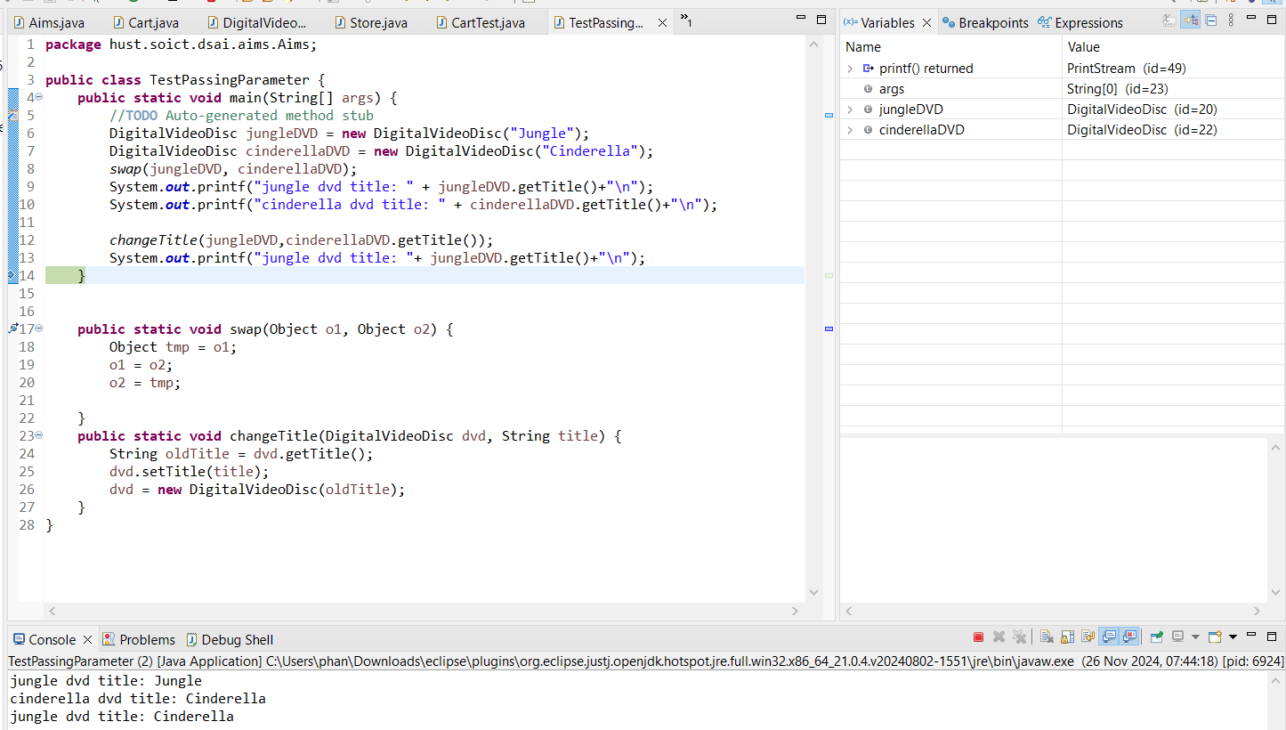

Classifier Member and Instance Member
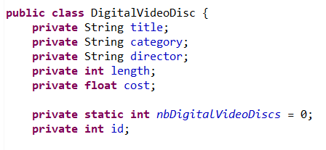
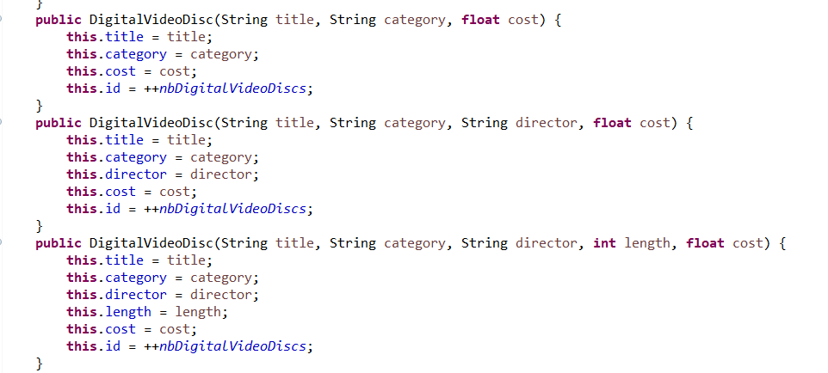
Open the Cart class
4. Write a toString() method for the DigitalVideoDisc class. What should be the return type of this method?
Answer: Should be String
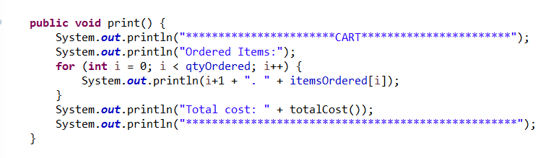
Implement Store class
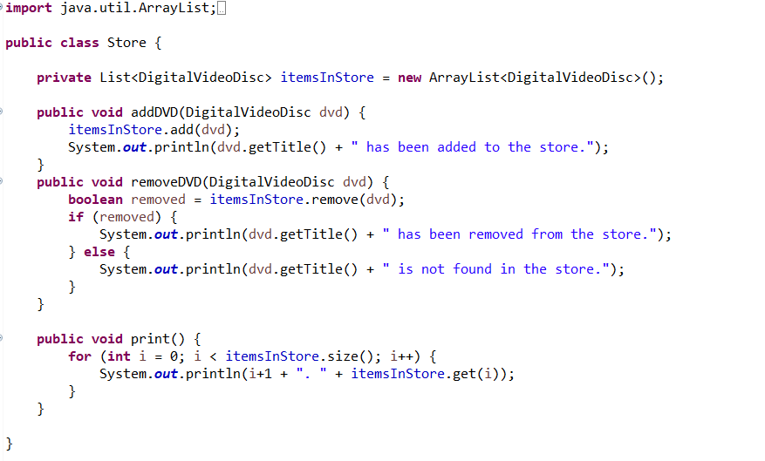
String, StringBuilder and StringBuffer
